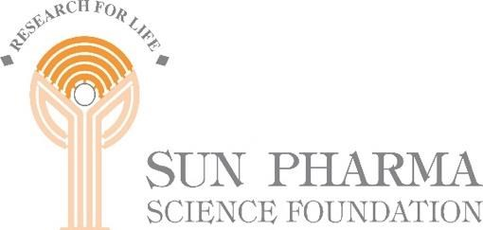

**Sun Pharma Science Foundation invites applications from *Early Career Clinicians in India* for training in the conduct of research**

Sun Pharma Science Foundation will award Clinical Research Fellowships to early career clinicians in India to obtain research training in R&D institutions in India to empower them to carry out independent clinical research. This Research Fellowship will be offered for a total duration of six months, which may be availed of by a selected applicant in one or more (not exceeding three) disjoint periods of time within three years from the award of the Research Fellowship. The training will comprise formal lectures, tutorials and hands-on research activities. The Fellowship will cover travel, board & lodging expenses and expenses for the conduct of hands-on research. A modest stipend may also be provided, if required.

An Assistant Professor employed in any Medical College in India will be eligible to be considered for this Research Fellowship. Preference will be given to an Assistant Professor who has obtained the first academic appointment within two years from the year of consideration for Fellowship.

Request you to kindly circulate this notification maximum and also place it on your notice board.

Thanks & Regards

**Prof. Virander S. Chauhan Dr. Amit Nasa**

**Chairman Member Secretary**

**Sun Pharma Science Foundation Sun Pharma Science Foundation**